bIG DATA ANALYTICS

# 22AIE312 – LABSHEET 4

Implement a MapReduce program to process weather data and find the highest temperature recorded by a weather station.

• Implement the Mapper class. The mapper should read the input text and extract the temperature from each record. Output the station ID as the key and the temperature as the value.

• Implement the Reducer class. The reducer should receive the key-value pairs from the mapper and find the maximum temperature for each station.

• Write the driver class to configure and run the MapReduce job.

## Start Hadoop

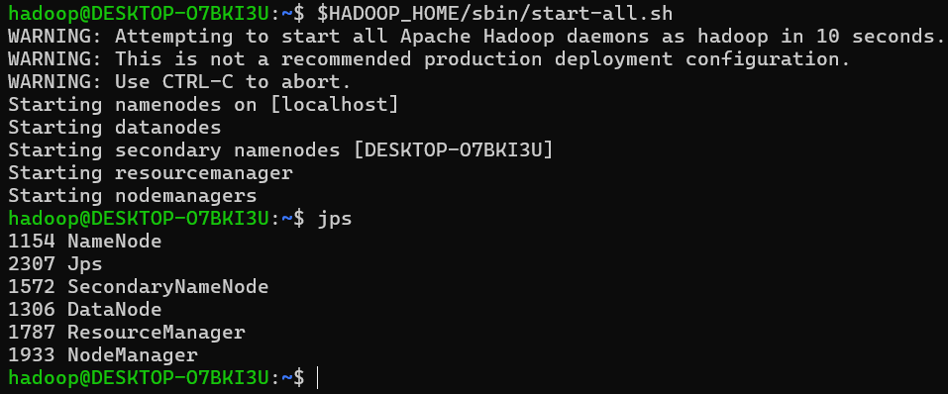

## Create and Upload Input Data to HDFS

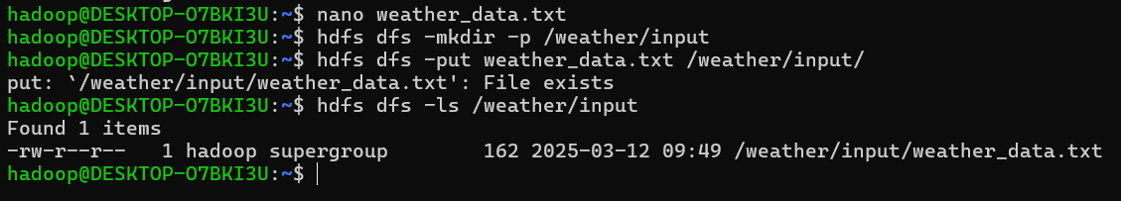

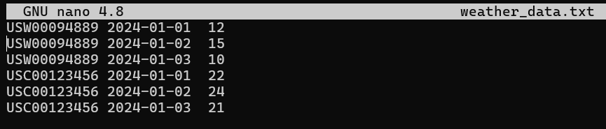

## MapReduce Program

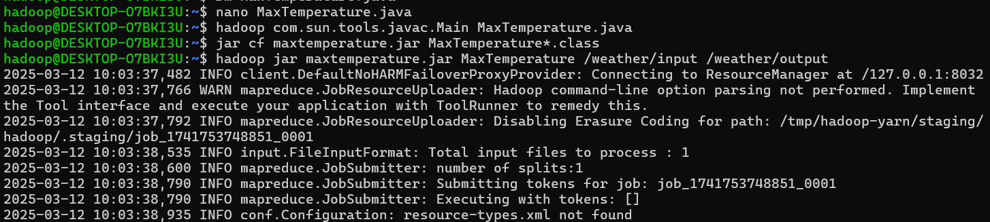

## Results

